Executive Summary

Project Overview
This project is responsible for creating a project Human Resource that describes in detail how the project will manage for human resource. This project the Human Resource Management is to ensure that the project has sufficient human resources, with the correct skill sets and experience, for the project to be successfully completed. For attendance of company employees and data of each department. The Human resource it can also communicate the Marketing and sales information for new employees to apply for the company.

Human resource is the organizational function that deals with issues related to people such as compensation, hiring, performance management, organization development, safety, wellness, benefits, employee motivation, communication, administration, and training. This system it has Scheduling and for job hiring for vacant position and it have attendance for the employee or the staff of the company. This project it helps the Human Resource to manage the employees and for the information of the employees.

Purpose and Scope of this Specification
The purpose of this specification and its intended audience. Include a description of what is within the scope what is outside of the scope of these specifications.
In scope:
- List of employee’s positions.
- Attendance for the employee.
- The system provides Sales and Marketing information when there is a vacancy and the job hiring posted by Sales and Marketing.
- The Admin or the Department monitors the report of the company.
- The Human Resource approves the leave of the employee.
- Employee file a leave
Out of Scope

- Payroll is not part of our projects.
- Human Resource does not post for the job hiring.

Product/Service Description
This project will help the Human Resource to facilitate the work and to provide information to other departments. Similar to Sales and Marketing, HR will need to provide first information on how to post Sales and Marketing for job hiring.

Product Context
In system there’s scheduling, attendance for employee it gives information about vacant position in sales marketing.

User Characteristics
Create general customer profiles for each type of user who will be using the product. Profiles should include:
- Student/faculty
- CECS
- Staff
- HR

Assumptions

In this project the human resource is systems that influence employee behavior and performance. Assumptions of personnel about managing people in several significantly. The Employee satisfaction is the key to productivity and quality. Human Resource is a process development, and maintenance of competent human force to achieve goals of an organization in an efficient.

Constraints
Describe any items that will constrain the design options, including
- Access, administration and security.
- Performance management and productivity
- Connection or the communication interrupt
- In webpage does not load the system faster.

Dependencies
List dependencies that affect the requirements. Examples:
- Attendance leaves and other performance of the employee from each department is needed.
- Attendance is send to Accounting and Finance for Pay Rolls of the employee.
- For hiring we need to get the information of the applicant from the Marketing Department that post the hiring page.
- HR Department should provide Policy for the company base on department.

Requirements
- Inputs to the creating the human resource requirements include the activity list, the human resource management plan, enterprise environmental factors and organizational process assets. Before you can determine how the resource requirements will be met, you must determine what they are. That’s the purpose of this human resource requirements document. It captures the activity name and the responsibility when it comes for hiring. Next, there’s a place for documenting the skills, degree or certification needed to complete the activity for training. It also includes a place to document the start date, end date and over all duration of the work.
- Proper planning will have to determining the required skills to place employees in the proper areas to work most efficiently. This could include hiring new staff or transferring employees from certain sections
Priority Definitions
The following definitions are intended as a guideline to prioritize requirements.
- Priority 1 – The requirement is a “must have” as outlined by policy/law
- Priority 2 – The requirement is needed for improved processing, and the fulfillment of the requirement will create immediate benefits
- Priority 3 – The requirement is a “nice to have” which may include new functionality
It may be helpful to phrase the requirement in terms of its priority, e.g., "The value of the employee status sent to DIS must be either A or I" or "It would be nice if the application warned the user that the expiration date was 3 business days away". Another approach would be to group requirements by priority category.
- A good requirement is:
- Correct
- Unambiguous
- Testable (verifiable)
- Clear (concise, terse, simple, precise)
- Understandable
- Feasible (realistic, possible)
- Independent
- Necessary
- Consistent
- Nonredundant
- Complete

Functional Requirements
In the example below, the requirement numbering has a scheme - BR_LR_0## (BR for Business Requirement, LR for Labor Relations). For small projects simply BR-## would suffice. Keep in mind that if no prefix is used, the traceability matrix may be difficult to create (e.g., no differentiation between '02' as a business requirement vs. a test case)
The following table is an example format for requirements. Choose whatever format works best for your project.
For Example:
Req# | Requirement | Comments | Priority | Date Rvwd | Reviewed / Approved
BR_LR_01 | The system should display all new applicants before approval. | Admin must see personal information of the applicants. | 1
BR_LR_02 | The system should display all new hired employee before delegation and scheduling | Admin can delegation a schedule the newly hired employee. | 2
BR_LR_03 | The system should capture all the performance of all the employee Based on:  (Attendance, leaves, laziness) | Admin need to monitor employee performance. | 2
BR_LR_04 | The system should record all the leaves and absences. | Admin need number of hours work’s in a day. | 3
BR_LR_05 | The system should send all attendance in the Accounting & Finance department. | Admin must keep all attendance of the employee.  . | 3
BR_LR_06 | The system should choose employee that needs training. | Admin can deploy any employee for training. | 2
BR_LR_07 | The system should delegate all new employee base in their skills. | Admin should identify if employee is regular or contractual | 3

User Interface Requirements
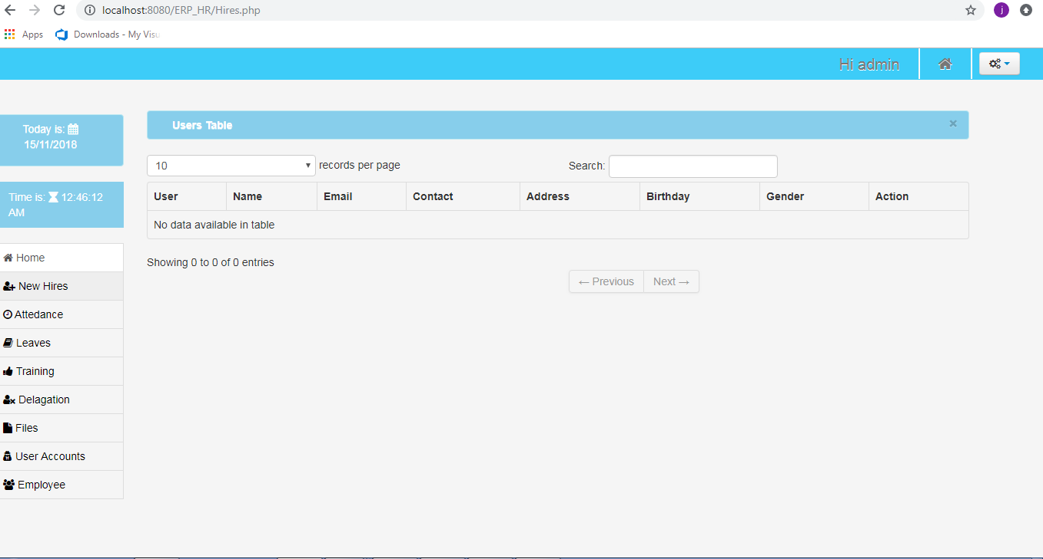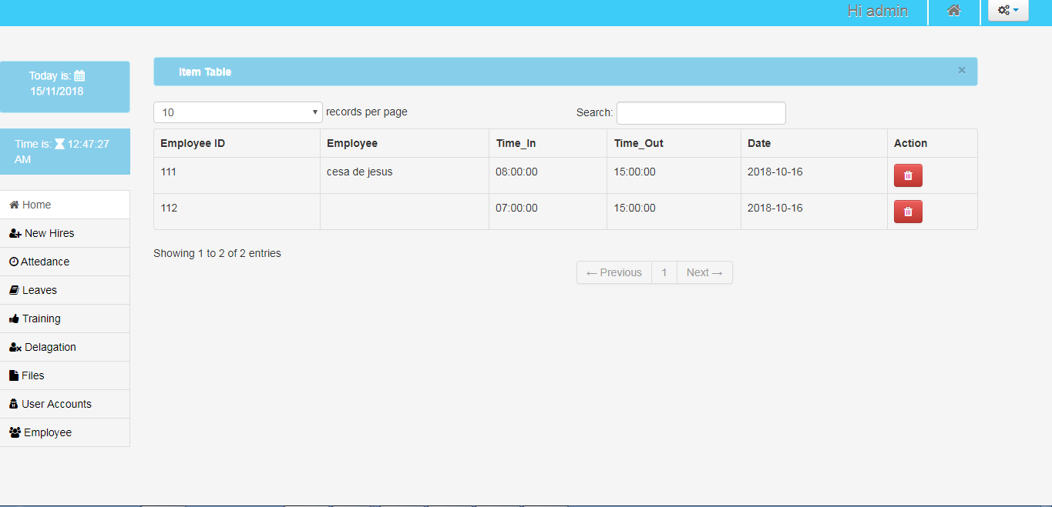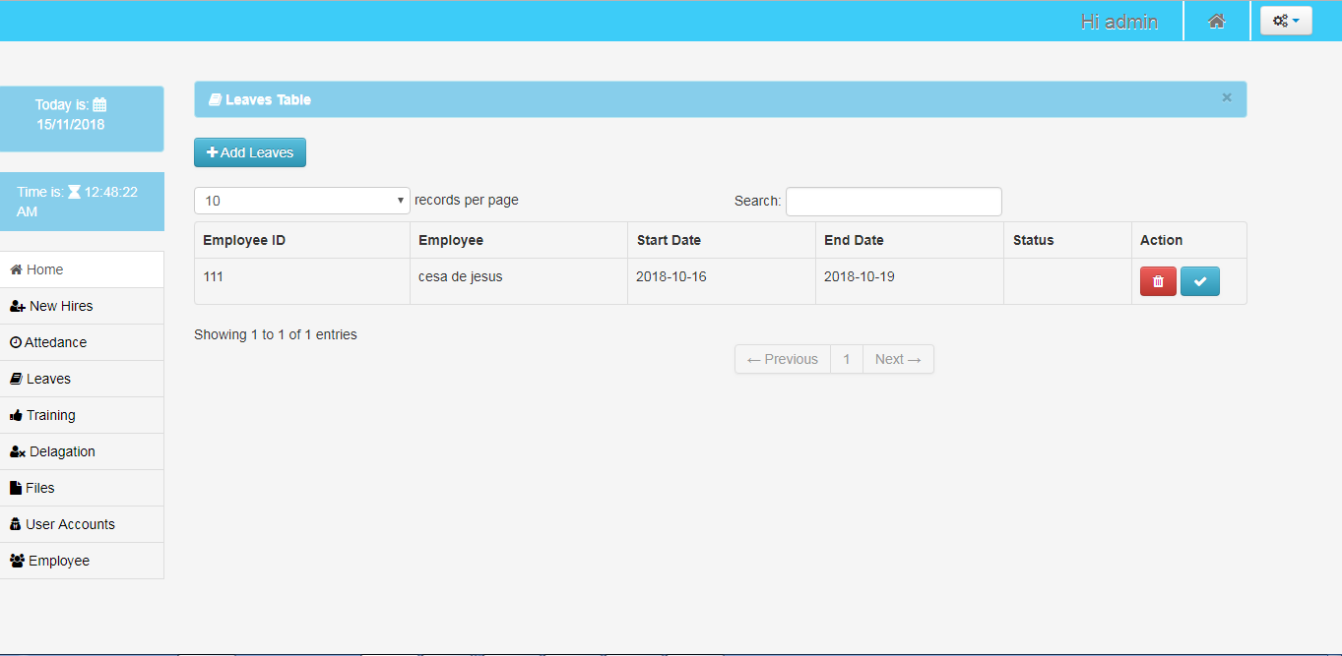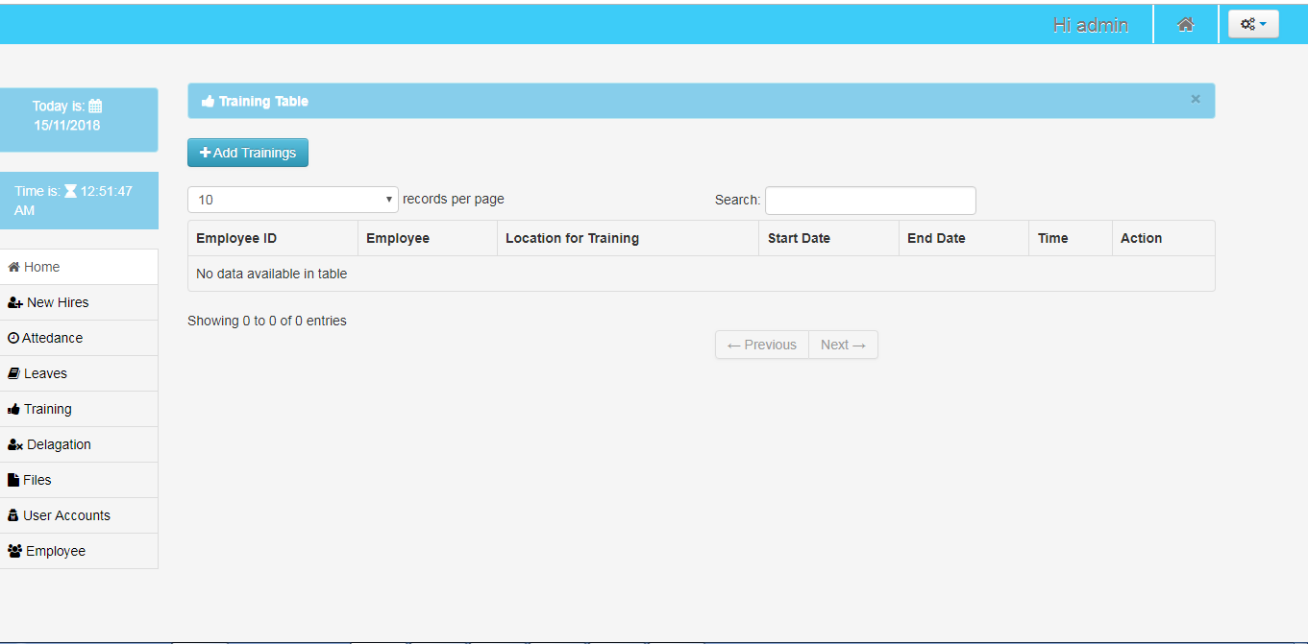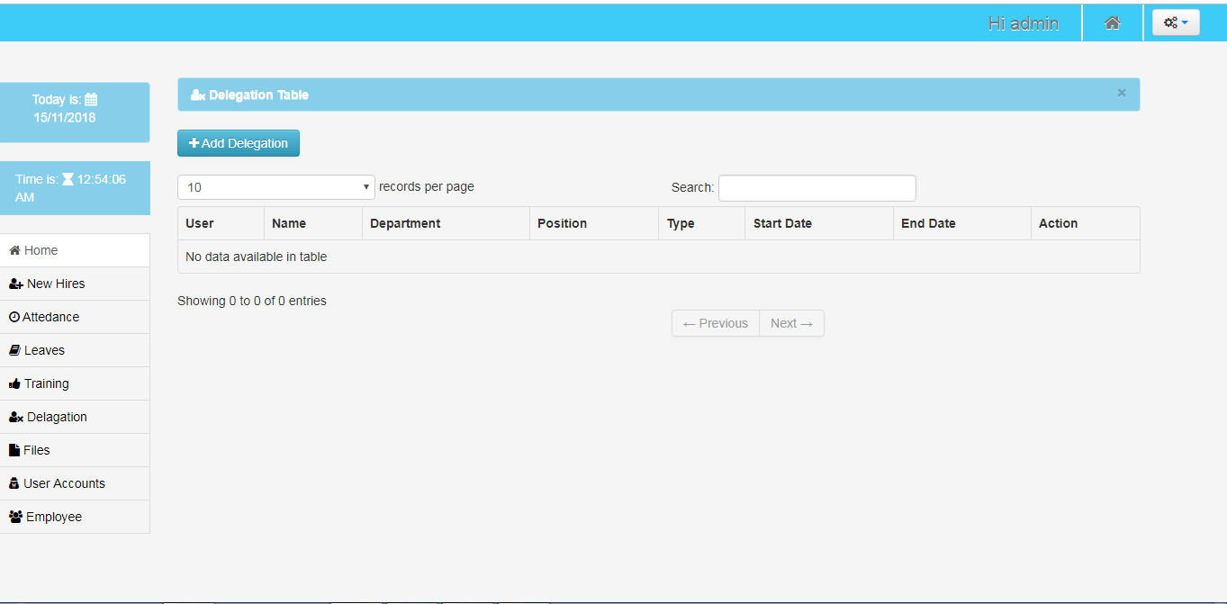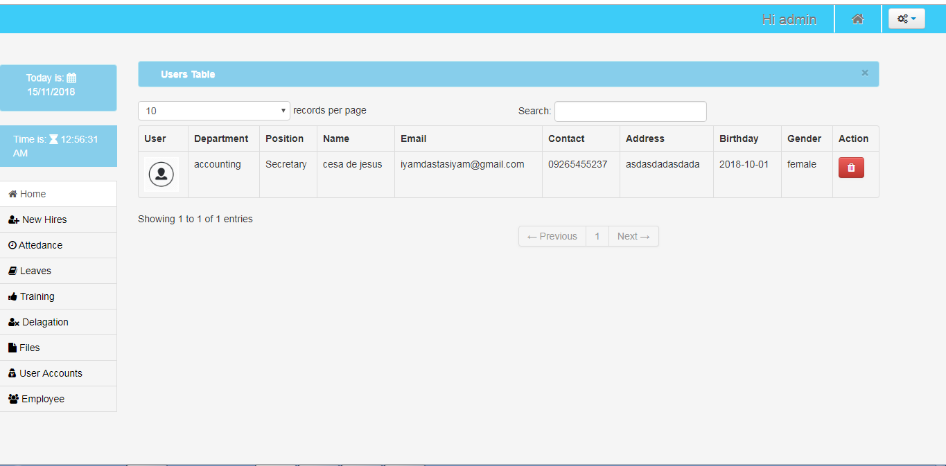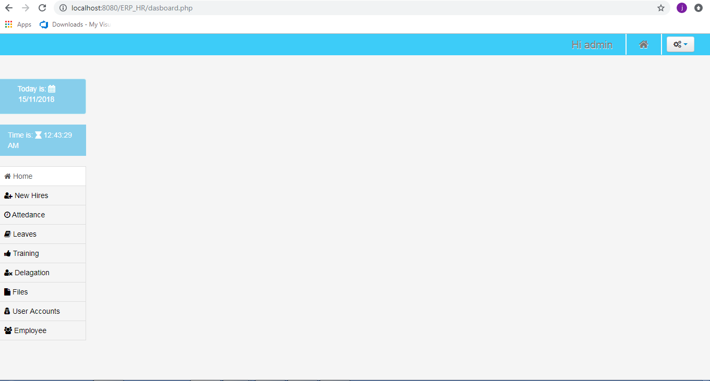

Usability
Include any specific usability requirements, for example,
Learnability
- The system should be easy to learn
- Users should always be assisted so that they will be able to smoothly output a potential output.
- The system helps a user makes a huge contribution to a partner of their project or work.
- The system of a job should be easy to learn for the good output.
- The functions are easy to use.
- To make easy your work.
- The system is user friendly.

Performance
Include any specific performance requirements
- The system should be improve to the employee effectiveness
- The system can promote the employee through monitoring their performance
- The process and procedures of the system including evaluation forms and templates

Capacity
There are different department that are connected in human resource allowing the organization to assess the capacity of employees based on the needed in business organization, in every department that are connected in human resource has ten employees each department.

Availability
Include specific and measurable requirements for:
- Identify the information of the employees
- Scheduling of the employees
- Record of attendance
- Delegation of the employees
- Benefits of the employees
- Hiring and Training

Latency
- In hiring we have 5 days to review the information of applicants.
- In leave we have 10 days to process.
- In training we have 1-week training.
- In resigning we have 1 month to process.

Manageability/Maintainability

Monitoring
- Attendance monitoring of the employees.
- Scheduling of the employees.
- Determine the employee’s status.
- Recording data to another department.
- Benefits of the employees

Maintenance
System need to maintain the functionality of each module and establish requirement and task to accomplish for achieving restoring and maintaining operational capability for the features of the system. Every changes of the data in sales and marketing need to update for the hiring of the employees.

Operations
During working hours, the system ensuring that all attendance of employees will monitored, updating the time in and time out of employees and hiring is also integrated in system.

System Interface/Integration
Specify the use of other required products (e.g., a database or operating system), and interfaces with other systems (e.g., UWHires package interfaces with PubCookie and ODS, HEPPS system interfaces with Budget system). For each interface, define the interface in terms of message format and content. For well-documented interfaces, simply provide a reference to the documentation.
Outline each interface between the product and the hardware or network components of the system. This includes configuration characteristics (e.g., number of ports, instruction sets), what devices are to be supported, and protocols (e.g., signal handshake protocols).

Network and Hardware Interfaces
Specify the logical characteristics of each interface between the product and the hardware or network components of the system. This includes configuration characteristics (e.g., number of ports, instruction sets), what devices are to be supported, and protocols (e.g., signal handshake protocols).

Systems Interfaces
Example systems interface requirements:
- System1-to-System2 Interface
The <external party> will create and send a fixed length text file as an email attachment to System2mail@u.washington.edu to be imported into the System2 system for payroll calculation. This file must be received on EDIT day by 4:00 PM in order to be processed in the EDIT night run. The requirements below document the file specifications, data transfer process, and specific schedule. This file is referred to as "FileName" in this document.
File Structure and Format
  - The FileName file is a fixed length text file.
  - The FileName file is an unformatted ASCII file (text-only).
  - The FileName file contains a batch totals record and several detail records.
File Description: Batch Totals Record
  - The batch totals record can be placed at the beginning, in the middle, or at the end of the file.
  - The batch totals record contains the following:
  - Total number of detail records
  - Total number of employees
  - Total of absenteeism
  - Total number of hiring
  - Total number of temporary/permanent employee (delegation)
File Description: Detail Records
  - The FileName file contains a row for each record meeting xxx criteria.
- New Hires
- Attendance
- Leaves
- Training
- Delegation
- Files
- User accounts
- Employee

Security

Security
These profiles determine who has access to what screen, which data elements or fields each person can have access to, and who will be authorized to change information, enter information, or merely view the information. Security profiles typically are attached to a job description or to an employee number.

Protection
Specify the factors that will protect the system from malicious or accidental access, modification, disclosure, destruction, or misuse. For example:
- encryption
- activity logging, historical data sets
- restrictions on intermodule communications
- data integrity checks

Authorization and Authentication
Specify the Authorization and Authentication factors. Consider using standard tools such as PubCookie.

Data Management
Specify the requirements for any information that is to be placed into a database, including
- types of information used by various functions
- frequency of use
- data access rules
- data entities and relationships
- integrity constraints
- data retention
- valid range, accuracy, and/or tolerance
- units of measure
- data formats
- default or initial values

Standards Compliance
Specify the requirements derived from existing standards, policies, regulations, or laws (e.g., report format, data naming, accounting procedures, audit tracing). For example, this could specify the requirement for software to trace processing activity. Such traces are needed for some applications to meet minimum regulatory or financial standards. An audit trace requirement may, for example, state that all changes to a payroll database must be recorded in a trace file with before and after values.

Portability
If portability is a requirement, specify attributes of the system that relate to the ease of porting the system to other host machines and/or operating systems. For example,
- Percentage of components with host-dependent code;
- Percentage of code that is host dependent;
- Use of a proven portable language;
- Use of a particular compiler or language subset;
- Use of a particular operating system;
- The need for environment-independence - the product must operate the same regardless of operating systems, networks, development or production environments.

User Scenarios/Use Cases
Provide a summary of the major functions that the product will perform. Organize the functions to be understandable to the customer or a first time reader. Include use cases and business scenarios, or provide a link to a separate document (or documents). A business scenario:
- Describes a significant business need
- Identifies, documents, and ranks the problem that is driving the scenario
- Describes the business and technical environment that will resolve the problem
- States the desired objectives
- Shows the “Actors” and where they fit in the business model
- Is specific, and measurable, and uses clear metrics for success

Deleted or Deferred Requirements
Identify any requirements that have been deleted after approval or that may be delayed until future versions of the system. For example:
Req# | Business Requirement | Status | Comments | Pri | Date Rvwd | SME Reviewed /Approved
BR_LR_01 | The system should validate the relationship between Bargaining Unit/Location and Job Class. | April 2005: Deleted.  This requirement has been replaced by BR_LR_036 and BR_CC_33. | Business Process = “Assigning a Bargaining Unit to an Appointment” | 1 | 7/13/04 | Bob Dylan, Mick Jagger
BR_LR_02 | The system should validate that the supervisor indicator is correct according to job class.  Deferred to Phase 2B: 3/29/2005 | April 2005: Deferred to Phase 2B. | Business Process = “Assigning a Bargaining Unit to an Appointment” | 3 | 7/13/04 | Bob Dylan, Mick Jagger
BR_LR_03 | The system should derive the bargaining unit code, union code, and supervisor indicator from the job class code and location. | April 2005: Deleted  Replaced by BR_LR_16 and BR_LR_17. | Business Process = “Assigning a Bargaining Unit to an Appointment”; This will eliminate the need, typically, for the user to enter the bargaining unit code, union code and supervisor indicator. | 1 | 7/13/04 | Bob Dylan, Mick Jagger

Requirements Confirmation/Stakeholder sign-off
Include documentation of the approval or confirmation of the requirements here. For example:
Meeting Date | Attendees (name and role) | Comments
7/13/07 | Bob Dylan, Labor Relations SME  Mick Jagger, Labor Relations SME  Ringo Starr, Technical Project Manager  Debbie Harry, Technical Analyst  Janis Joplin, Technical Analyst  Fred Meyer, Project Manager | Confirmed BR_LR_01 – BR_LR_15
04/15/05 | Bob Dylan, Labor Relations SME  Mick Jagger, Labor Relations SME  Ringo Starr, Technical Project Manager | Deferred / Deleted: BR_LR_01 - BR_LR_04, BR_LR_07, BR_LR_12, BR_LR_14, BR_LR_15, BR_LR_06, BR_LR_17

APPENDIX
The appendixes are not always considered part of the actual Requirements Specification and are not always necessary. They may include
- Sample input/output formats, descriptions of cost analysis studies, or results of user surveys;
- Supporting or background information that can help the readers of the Requirements Specification;
- A description of the problems to be solved by the system;
- Special packaging instructions for the code and the media to meet security, export, initial loading, or other requirements.
When appendixes are included, the Requirements Specification should explicitly state whether or not the appendixes are to be considered part of the requirements.
- Definitions, Acronyms, and Abbreviations
Define all terms, acronyms, and abbreviations used in this document.
- References
List all the documents and other materials referenced in this document.
- Requirements Traceability Matrix
The following trace matrix examples show one possible use of naming standards for deliverables (FunctionalArea-DocType-NN). The number has no other meaning than to keep the documents unique. For example, the Bargaining Unit Assignment Process Flow would be BUA-PF-01.
For example (1):
Business Requirement | Area | Deliverables | Status
BR_LR_01  The system should validate the relationship between Bargaining Unit/Location and Job Class.---Comments: Business Process = "Assigning a Bargaining Unit to an Appointment" (Priority 1) | BUA | BUA-CD-01  Assign BU Conceptual Design | Accepted
 | BUA | BUA-PF-01  Derive Bargaining Unit-Process Flow Diagram | Accepted
 | BUA | BUA-PF-01  Derive Bargaining Unit-Process Flow Diagram | Accepted
BR_LR_09  The system should provide the capability for the Labor Relations Office to maintain the job class/union relationship.---Comments: Business Process = "Maintenance" (Priority 1) | BUA | BUA-CD-01  Assign BU Conceptual Design | Accepted
 | BUA | BUA-PF-02  BU Assignment Rules Maint Process Flow Diagram | ReadyForReview
For example (2):
BizReqID | Pri | Major Area | DevTstItems DelivID | Deliv Name | Status
BR_LR_01 | 1 | BUA | BUA-CD-01 | Assign BU Conceptual Design | Accepted
BR_LR_01 | 1 | BUA | BUA-DS-02 | Bargaining Unit Assignment DB Modification Description | Accepted
BR_LR_01 | 1 | BUA | BUA-PF-01 | Derive Bargaining Unit-Process Flow Diagram | Accepted
BR_LR_01 | 1 | BUA | BUA-UCD-01 | BU Assign LR UseCase Diagram | ReadyForReview
BR_LR_01 | 1 | BUA | BUA-UCT-001 | BU Assignment by PC UseCase - Add Appointment and Derive UBU | Reviewed
BR_LR_01 | 1 | BUA | BUA-UCT-002 | BU Assignment by PC UseCase - Add Appointment (UBU Not Found) | Reviewed
BR_LR_01 | 1 | BUA | BUA-UCT-006 | BU Assignment by PC UseCase - Modify Appointment (Removed UBU) | Reviewed
BR_LR_09 | 1 | BUA | BUA-CD-01 | Assign BU Conceptual Design | Accepted
BR_LR_09 | 1 | BUA | BUA-DS-02 | Bargaining Unit Assignment DB Modification Description | Accepted
BR_LR_09 | 1 | BUA | BUA-PF-02 | BU Assignment Rules Maint Process Flow Diagram | Accepted
BR_LR_09 | 1 | BUA | BUA-UCD-03 | BU Assign Rules Maint UseCase Diagram | Reviewed
BR_LR_09 | 1 | BUA | BUA-UCT-045 | BU Assignment Rules Maint: Successfully Add New Assignment Rule | Reviewed
BR_LR_09 | 1 | BUA | BUA-UCT-051 | BU Assignment Rules MaintUseCase: Modify Rule | Reviewed
BR_LR_09 | 1 | BUA | BUA-UCT-053 | BU Assignment Rules MaintUseCase - Review Assignment Rules | Reviewed
BR_LR_09 | 1 | BUA | BUA-UCT-057 | BU Assignment Rules MaintUseCase: Inactivate Last Rule for a BU | Reviewed
BR_LR_09 | 1 | BUA | BUA-UI-02 | BU AssignRules Maint UI Mockups | ReadyForReview
BR_LR_09 | 1 | BUA | BUA-TC-021 | BU Assignment Rules Maint TestCase: Add New Rule (Associated Job Class Does Not Exist) - Success | ReadyForReview
BR_LR_09 | 1 | BUA | BUA-TC-027 | BU Assignment Rules Maint TestCase: Modify Rule - Success | ReadyForReview
BR_LR_09 | 1 | BUA | BUA-TC-035 | BU Assignment Rules Maint TestCase: Add New Rule (Associated Job Class Does Not Exist) - Error Condition | ReadyForReview
BR_LR_09 | 1 | BUA | BUA-TC-049 | BU Assignment Rules Maint TestCase: Modify Rule - Error Condition | ReadyForReview
For example (3):
BizReqID | CD01 | CD02 | CD03 | CD04 | UI01 | UI02 | UCT01 | UCT02 | UCT03 | TC01 | TC02 | TC03 | TC04
BR_LR_01 |  |  | X |  | X |  | X |  |  | X |  | X
BR_LR_09 | X |  |  | X |  | X |  |  | X |  | X |  | X
BR_LR_10 | X |  |  | X |  |  |  |  | X |  | X
BR_LR_11 |  | X
- Organizing the Requirements
This section is for information only as an aid in preparing the requirements document.
Detailed requirements tend to be extensive. Give careful consideration to your organization scheme. Some examples of organization schemes are described below:
By System Mode
Some systems behave quite differently depending on the mode of operation. For example, a control system may have different sets of functions depending on its mode: training, normal, or emergency.
By User Class
Some systems provide different sets of functions to different classes of users. For example, an elevator control system presents different capabilities to passengers, maintenance workers, and fire fighters.
By Objects
Objects are real-world entities that have a counterpart within the system. For example, in a patient monitoring system, objects include patients, sensors, nurses, rooms, physicians, medicines, etc. Associated with each object is a set of attributes (of that object) and functions (performed by that object). These functions are also called services, methods, or processes. Note that sets of objects may share attributes and services. These are grouped together as classes.
By Feature
A feature is an externally desired service by the system that may require a sequence of inputs to affect the desired result. For example, in a telephone system, features include local call, call forwarding, and conference call. Each feature is generally described in a sequence of stimulus-response pairs, and may include validity checks on inputs, exact sequencing of operations, responses to abnormal situations, including error handling and recovery, effects of parameters, relationships of inputs to outputs, including input/output sequences and formulas for input to output.
By Stimulus
Some systems can be best organized by describing their functions in terms of stimuli. For example, the functions of an automatic aircraft landing system may be organized into sections for loss of power, wind shear, sudden change in roll, vertical velocity excessive, etc.
By Response
Some systems can be best organized by describing all the functions in support of the generation of a response. For example, the functions of a personnel system may be organized into sections corresponding to all functions associated with generating paychecks, all functions associated with generating a current list of employees, etc.
By Functional Hierarchy
When none of the above organizational schemes prove helpful, the overall functionality can be organized into a hierarchy of functions organized by common inputs, common outputs, or common internal data access. Data flow diagrams and data dictionaries can be used to show the relationships between and among the functions and data.
Additional Comments
Whenever a new Requirements Specification is contemplated, more than one of the organizational techniques given above may be appropriate. In such cases, organize the specific requirements for multiple hierarchies tailored to the specific needs of the system under specification.
There are many notations, methods, and automated support tools available to aid in the documentation of requirements. For the most part, their usefulness is a function of organization. For example, when organizing by mode, finite state machines or state charts may prove helpful; when organizing by object, object-oriented analysis may prove helpful; when organizing by feature, stimulus-response sequences may prove helpful; and when organizing by functional hierarchy, data flow diagrams and data dictionaries may prove helpful.

